OFFICE OF INTERNAL AUDIT CHARTER

Action Requested: Receive and Approve the Office of Internal Audit Charter.

Executive Summary: On an annual basis, or as necessary, the Office of Internal Audit Charter should be reviewed and approved.

Background: Policy Manual §2.2(9) establishes an internal audit function for the Board of Regents. Internal audit, as defined by the Institute of Internal Auditors, is an independent, objective, assurance and advisory service designed to add value and improve an organization’s operations.

The Office of Internal Audit Charter constitutes the framework for the internal audit function and defines its mandate, authority, duties, reporting obligations and resources. Adoption of this Charter will strengthen the oversight function within the Board of Regents and align it with best business practices.
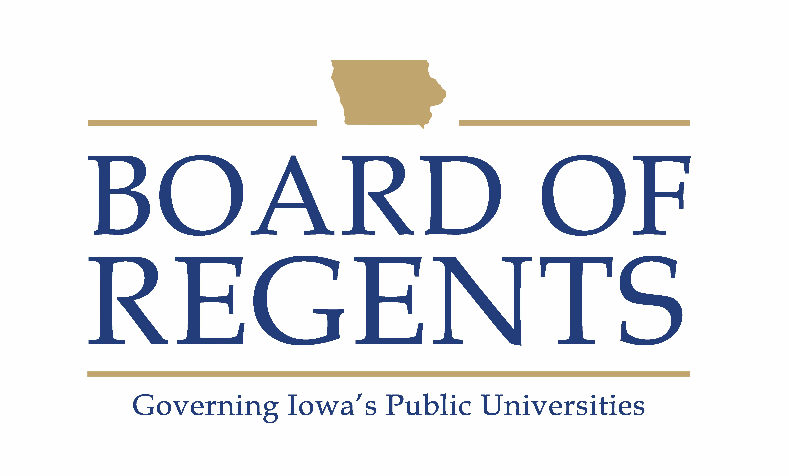

OFFICE OF INTERNAL AUDIT CHARTER

PURPOSE
The purpose of the internal audit function is to strengthen the Iowa Board of Regents (BOR) universities’ ability to create, protect, and sustain value by providing the BOR and management with independent, risk-based, and objective assurance, advice, insight, and foresight. The internal audit function enhances BOR institution’s successful achievement of their objectives; governance, risk management, and control processes; decision-making and oversight; reputation and credibility with its stakeholders; and ability to serve the public interest.

The Iowa BOR internal audit function is most effective when internal auditing is performed by competent professionals in conformance with The Institute of Internal Auditors (IIA) Global Internal Audit Standards; the internal audit function is independently positioned with direct accountability to the BOR; and internal auditors are free from undue influence and committed to making objective assessments.

MANDATE
The Office of Internal Audit’s mandate is to provide independent, objective assurance and advisory services designed to add value to and strengthen the management of the BOR and its institutions. The Office of Internal Audit helps the organization achieve its objectives by bringing a systematic, disciplined approach to evaluating and improving the effectiveness of risk management, control, and governance processes.

AUTHORITY
The internal audit function’s authority is created by its direct reporting relationship to the BOR. Such authority allows for unrestricted access to the BOR. The BOR has authorized the Chief Audit Executive (CAE) and staff to:
- Have full and unrestricted access to all functions, data, records, information, physical property, and personnel pertinent to carrying out internal audit responsibilities within the scope of engagements being performed. Internal auditors are accountable for confidentiality and safeguarding records and information.
- Have full and free access to the BOR.
- Allocate resources, set frequencies, select subjects, determine scopes of work, apply techniques, and issue communications to accomplish audit objectives.
- Obtain the necessary assistance of personnel in units of the organization and other specialized services from within or outside the organization to complete internal audit services.

INDEPENDENCE, ORGANIZATIONAL POSITION, AND REPORTING RELATIONSHIPS
The CAE is positioned at a level in the organization that enables internal audit services and responsibilities to be performed without interference from management, thereby establishing the independence of the internal audit function. The CAE is appointed by the BOR and reports functionally to the Audit and Compliance Committee and administratively to the Executive Director of the BOR Office. All audit staff report directly to the CAE and as of July 1, 2021, are employees of the BOR Office. Audit activities and reports are communicated to the university presidents and the BOR. This positioning provides the organizational authority and status to bring matters directly to senior management and escalate matters to the BOR, when necessary, without interference and supports the internal auditors’ ability to maintain objectivity.

The CAE will disclose to the BOR any interference internal auditors encounter related to Internal Audit’s full and unrestricted access to all functions, data, records, information, physical property, and personnel; and matters related to the scope, performance, and communication of internal audit work and results.

OBJECTIVITY
The internal audit function will remain free from all conditions that threaten the ability of internal auditors to carry out their responsibilities in an unbiased manner, including matters of engagement selection, scope, procedures, frequency, timing, and communication. If the CAE determines that objectivity may be impaired in fact or appearance, the details of the impairment will be disclosed to appropriate parties.

Internal auditors will maintain an unbiased mental attitude that allows them to perform engagements objectively such that they believe in their work product, do not compromise quality, and do not subordinate their judgment on audit matters to others, either in fact or appearance.

Internal auditors will have no direct operational responsibility or authority over any of the activities they review. Accordingly, internal auditors will not implement internal controls, develop procedures, install systems, make management decisions, or engage in other activities that may impair their judgment, including:
- Assessing specific operations for which they had responsibility within the previous year.
- Performing operational duties for BOR universities or its affiliates.
- Initiating or approving transactions external to the internal audit function.
- Directing the activities of any employee that is not employed by the internal audit function, except to the extent that such employees have been appropriately assigned to internal audit teams or to assist internal auditors.
Therefore, review and appraisal by the Office of Internal Audit does not in any way substitute or relieve other persons in the Regent universities of the responsibilities assigned to them.

BOR OVERSIGHT
The BOR Audit and Compliance Committee responsibilities are outlined in Policy manual §1.2.

MANAGING THE INTERNAL AUDIT FUNCTION
The CAE has the responsibility to:
- At least annually, develop a flexible annual audit plan using appropriate risk-based methodology, including any risks or control concerns identified by management, and submit that plan to the BOR for review and approval.
- Implement the annual audit plan, as approved, including, and as appropriate, any special tasks or projects requested by management and the BOR.
- Provide information periodically on the status and results of the annual audit plan and the sufficiency of internal audit resources.
- Maintain a professional audit staff with sufficient knowledge, skills, experience, and certifications to meet the requirements of the Global Internal Audit Standards and this Charter.
- Ensure audit activities are performed in accordance with the IIA’s Global Internal Audit Standards.
- Establish a quality assurance program by which the CAE assures the operation of internal auditing activities.
- Evaluate and assess new or changing services, processes, operations, and controls concurrent with their development, implementation, and/or expansion.
- Perform advisory services, beyond assurance services, to assist management in meeting its objectives. Examples may include facilitation, process design, and training.
- Issue periodic reports to the BOR and management summarizing results of audit activities.
- Consider emerging trends and successful practices in internal auditing.
- Assist in the investigation of significant suspected fraudulent activities within the organization and notify management and the BOR of the results.
- Coordinate activities and consider relying upon the work of other internal and external providers of assurance and advisory services for the purpose of providing optimal audit coverage to the organization.
- Report significant issues related to the processes for controlling the activities of the organizations and its affiliates, including potential improvements to those processes, and provide information concerning such issues through resolution.

SCOPE AND TYPES OF INTERNAL AUDIT SERVICES
The scope of internal audit services covers the entire breadth of the organization, including all the BOR institution’s activities, assets, and personnel. The scope of internal audit activities also encompasses but is not limited to objective examinations of evidence to provide independent assurance and advisory services to the BOR and management on the adequacy and effectiveness of governance, risk management, and control processes for the BOR institutions.

The nature and scope of advisory services may be agreed with the party requesting the service, provided the internal audit function does not assume management responsibility. Opportunities for improving the efficiency of governance, risk management, and control processes may be identified during advisory engagements. These opportunities will be communicated to the appropriate level of management. Internal audit engagements may include evaluating whether:
- Risks are appropriately identified and managed.
- Significant financial, managerial, and operating information is accurate, reliable, and timely.
- Operations are compliant with policies, standards, procedures, and applicable laws and regulations.
- Resources are acquired economically, used efficiently, and are adequately protected.
- Programs, plans, and objectives are achieved.
- Quality and continuous improvement are fostered in the organizations’ control process.

Last approved by the Board: February 27, 2025

